1. [Pain in Endometriosis](https://sci-hub.se/10.3389/fncel.2020.590823)-
2. [Pain in endometriosis, classification of stages](https://sci-hub.se/10.7759/cureus.3361)-
3. [Endometriosis stages](https://www.advancedgynaecologymelbourne.com.au/endometriosis/stages#:~:text=The%20classification%20also%20uses%20a,indicate%20moderate%20or%20severe%20disease.)-
4. [IL-8 Conc in various stages](https://sci-hub.se/10.1016/S0015-0282(16)57506-2)
5. *[Pathogenetic significance of increased il-8 in peritoneal fluid in patients with endometriosis](https://sci-hub.se/10.1016/S0015-0282(98)00049-1)-VERY RELEVANT(graph included) -Correlation between the active lesion score and the peritoneal fluid concentration of IL-8 in women with endometriosis. A significant positive correlation was observed.
6. [Correlation of angiogenic cytokines-leptin and IL-8 in stage, type and presentation of endometriosis](https://sci-hub.se/10.3109/09513590.2011.593664)
7. [The staging of peritoneal endometriosis by the type of active lesion in addition to the revised American Fertility Society classification*](https://www.sciencedirect.com/science/article/pii/S0015028216561615?via%3Dihub)
8. [Paper with an example of how active lesion score is assigned](https://sci-hub.se/10.1016/S0002-9378(97)70553-2)
9. [Classification of endometriosis,rASRM classification](https://www.e-jyms.org/journal/view.php?doi=10.12701/yujm.2020.00444)- To understand how scores are assigned.

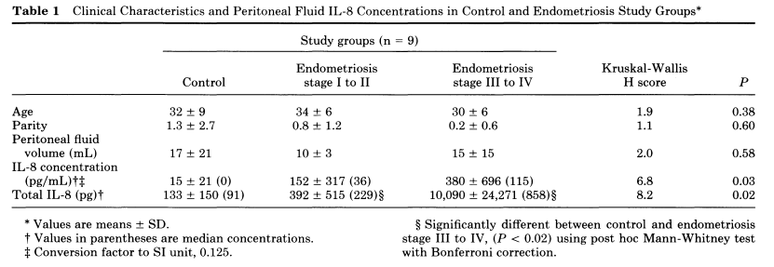

Table in paper 4

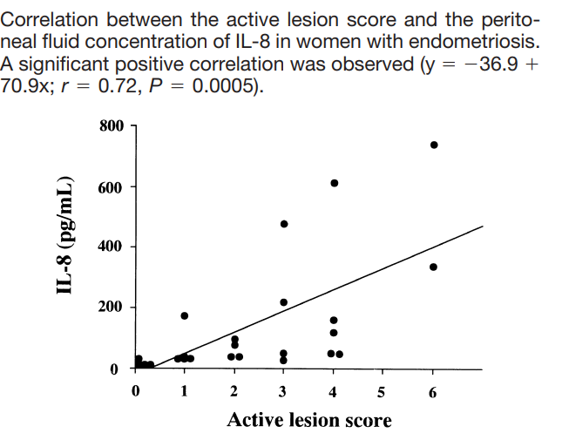

Graph given in paper 5

